**Fibonacci Sequence**

The Fibonacci sequence is a sequence of numbers which continue by adding the last number to the number that came previously before it, starting either with 0 and 1, or 1 and 1. In the following example, I will assume my starting numbers are 1 and 1.

An interesting application of the Fibonacci sequence is when it is applied to the speed at which rabbits procreate. Rabbits are able to mate at the end of one month, producing a pair of rabbits one month later. If we consider a situation where we have one pair of rabbits, the pair will mate after the first month, leaving us still with one pair. Then after the second month, we will have two pairs, one being the original and the other being the new pair. Then after the third month we will have three pairs, as the original pair will have produced another pair by this time. Then, after the fourth month, we will have two more pairs, one coming from the original pair and the other from the second pair produced. Giving us pairs 1, 1, 2, 3, 5 and so on. Please see the diagram below:

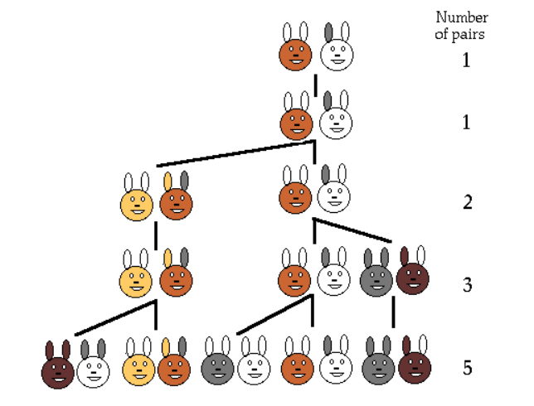

There is a closed form solution which defines how the sequence works, known as “Binet’s formula”. Using this formula, we can easily check whether a number is part of the Fibonacci sequence through a simple if statement. The rearranged mathematical formula can be found here:

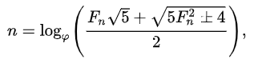

Some very smart people have taken this formula and ultimately figured out that you can determine if a number is part of the Fibonacci sequence, if and only if, 5x2+4 or 5x2-4 is a perfect square.

Sources: <http://www.maths.surrey.ac.uk/hosted-sites/R.Knott/Fibonacci/fibnat.html>

<https://en.wikipedia.org/wiki/Fibonacci_number>